Fama-French Factor Analysis of Kellanova Stock Returns

Part (1) Introduction
The first phase of the project required accessing the WRDS portal at
http://wrds.wharton.upenn.edu/. After reaching the site, I created a user account and logged in.
The next task was to download the Fama-French factor data from WRDS, which provides the variables used in the analysis: the risk-free rate (RFR), small minus big (SMB), high minus low (HML), and the excess market return (EMR). The RFR reflects a return with essentially zero default risk, SMB represents the performance gap between small-cap and large-cap firms, HML captures the return difference between high and low book-to-market stocks, and EMR shows the additional return associated with taking on broad market risk. The data extraction procedure was:
- Step 1: Click the “Get Data” menu.
- Step 2: Select “Data Dashboard.”
- Step 3: Open the “Third Party” section.
- Step 4: Choose “Fama French Portfolios and Factors.”
- Step 5: Select “3 Factors Plus Momentum – Monthly Frequency.”
- Step 6: Under “Step 1: Choose your date range,” set the start date to “1980-01” by clicking the date field and scrolling back to 1980, then selecting “Jan.” Repeat this process to set the end date to “2017-12.”
- Step 7: In “Step 2: Choose factors for query,” check every option except momentum. The help icons provide short explanations that may assist with interpreting the factors.
- Step 8: In “Step 3: Select Query Output,” choose “Excel spreadsheet (*.xlsx),” select “None” for compression, and pick any date format.
- Step 9: Click the “Submit Query” button. After processing is complete, a download link will appear that opens an Excel file containing the monthly Fama-French factors.
This spreadsheet will provide the base case information as we go through the rest of this process. After collecting the 456 row spreadsheet, the next step is to collect the data for a specific company. In my case I chose Kellanova (formerly Kellogg) since they had an early IPO (January 9, 1952). They recently, on October 2, 2023, split into two separate companies. Kellanova for their snacks and WK Kellogg Co for their cereals. Kellanova still trades under the original ticker 'K' while WK Kellogg Co uses the ticker ‘KLG.’ However for the purpose of this project (and since our timeline only goes to 2017) This information is irrelevant to our analysis.
The process for collecting data from the WRDS portal is as follows:
- Step 1: Navigate to the “Get Data” section.
- Step 2: Select “CRSP.”
- Step 3: Choose the “Stock/Security File.”
- Step 4: Open the “Monthly Stock File” option.
- Step 5: In “Step 1: Choose your date range,” adjust the starting date to “1980-01.” This requires clicking the date field and scrolling back to 1980, then selecting “Jan.” Repeat the same procedure for the end date so it reads “2017-12.”
- Step 6: Enter Kellanova’s ticker symbol (‘K’) or a different stock of your choice.
- Step 7: In the time series variables, select only PRC, which represents the stock price.
  - For our purposes we will be ignoring the effects of stock splits and simply focusing on the price of the stock.
- Step 8: Under “Step 3: Select Query Output,” choose “Excel spreadsheet (*.xlsx),” select “None” for compression, and pick any preferred date format.
- Step 9: Click “Submit Query” to generate the output.
To wrap up part one, both the Fama-French Factors spreadsheet and the CRSP output were copied into the same spreadsheet, with special attention to the dates as to not misalign them. An 8th column (G) was added to calculate the monthly return. This was done by subtracting the new price from the old price, then dividing by the old price.
Part (2) Regression Analysis
To start the regression analysis the Analysis ToolPak had to be installed. This can be done by going into the Excel Add-ins section and clicking the box next to “Analysis ToolPak” which will provide access to the Data Analysis Tab.
After installing and activating the Data Analysis ToolPak in Excel, which is required for running regressions, I estimated a regression model designed to examine how Kellanova’s monthly stock returns relate to key Fama-French factors. In this model, the dependent variable was the stock return, while the independent variables consisted of the excess market return (EMR), the small-minus-big factor (SMB), and the high-minus-low factor (HML). By running this regression, I obtained several coefficients, significance levels, and other statistics that describe how each factor contributes to Kellanova's return behavior. The results generated from these steps form the basis for the analysis and interpretations presented in the following section of the report. The steps for this is as follows:
- Step 1: Open the Data Analysis ToolPak from the Data tab in Excel and choose the regression option.
- Step 2: Specify the full range of values for the independent variable and the corresponding range for the dependent variable, starting from the company’s first available return. For Kellanova, this involved 456 observations covering 1980 through 2017,
- Step 3: Ensure you select the “New Workbook Ply” and “Line Fit Plot” boxes
- Step 4: Select “OK” to generate your new sheet.
Excess Market Return Analysis
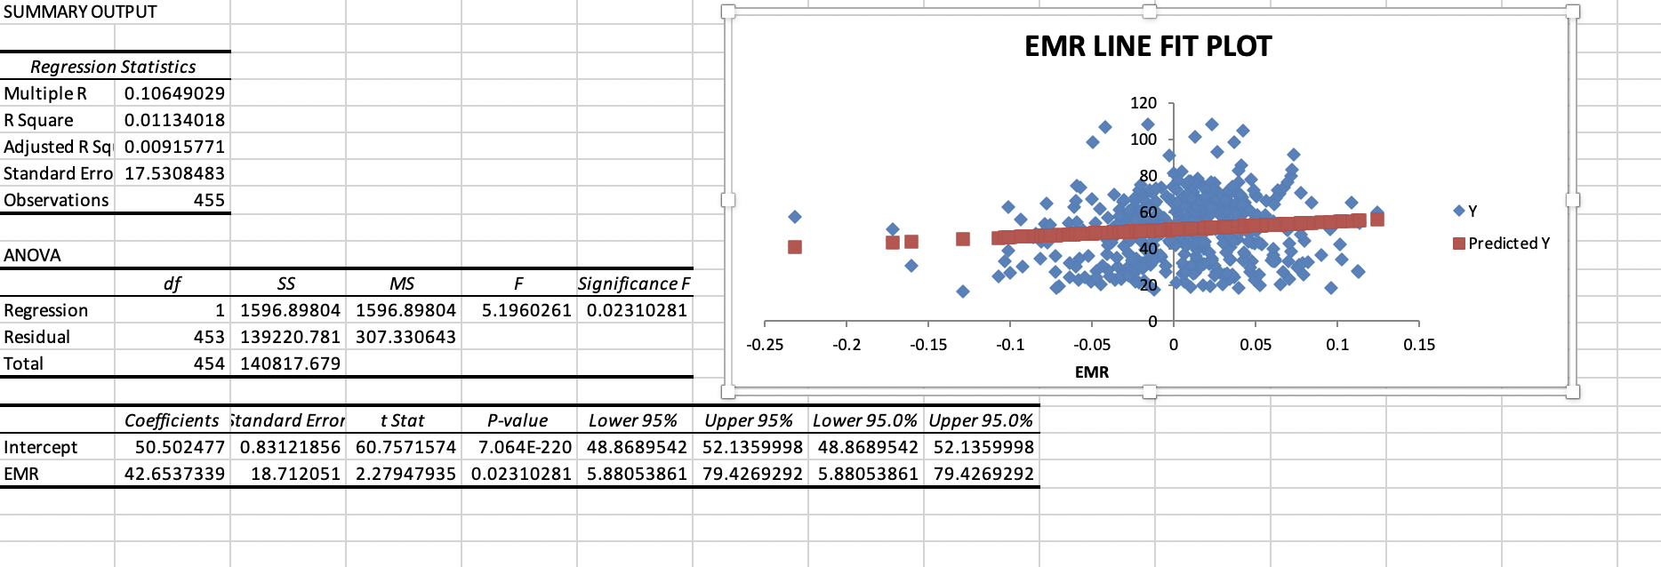Small Minus Big
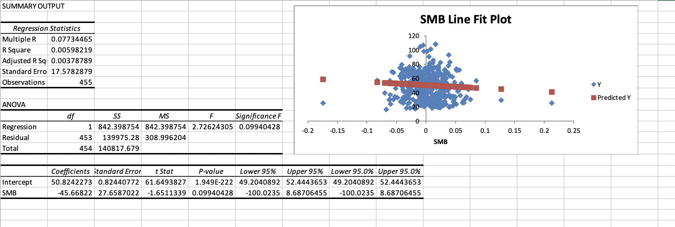High Minus Low
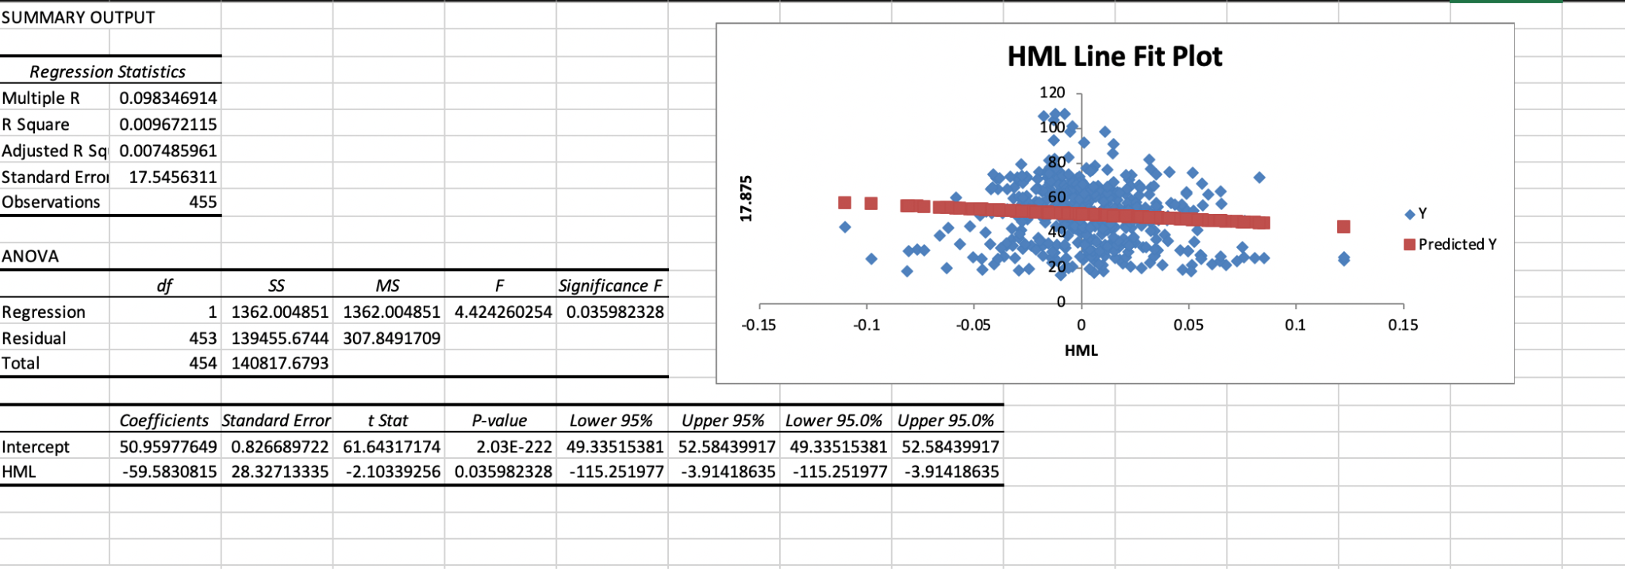
2B:
After compiling the necessary data, I estimated the regression model to analyze how Kellanova’s monthly stock returns respond to the core Fama-French factors. As mentioned before, the stock return served as the dependent variable, while the independent variables included the risk-free rate (RFR), the excess market return (EMR), the small-minus-big factor (SMB), and the high-minus-low factor (HML). This combined regression allowed me to evaluate the explanatory power of the variables and assess how each factor contributes to Kellanova’s return behavior. The resulting coefficients, significance levels, and model statistics form the basis of the analysis discussed in the next section. The steps to get this data is as follows:
- Step 1: Open the Data Analysis ToolPak from the Data tab in Excel and choose the regression function.
- Step 2: Specify the full data ranges for the dependent variable and all independent variables, beginning with the company’s first recorded return. For Kellanova, this required selecting 456 observations across five columns (A–D and F), covering the period from 1980 through 2017.
- Step 3: Choose the option to output the results to a “New Worksheet Ply”, leaving the line-fit plot unchecked.
- Step 4: Confirm the setup by selecting “OK.”
That produces this data:
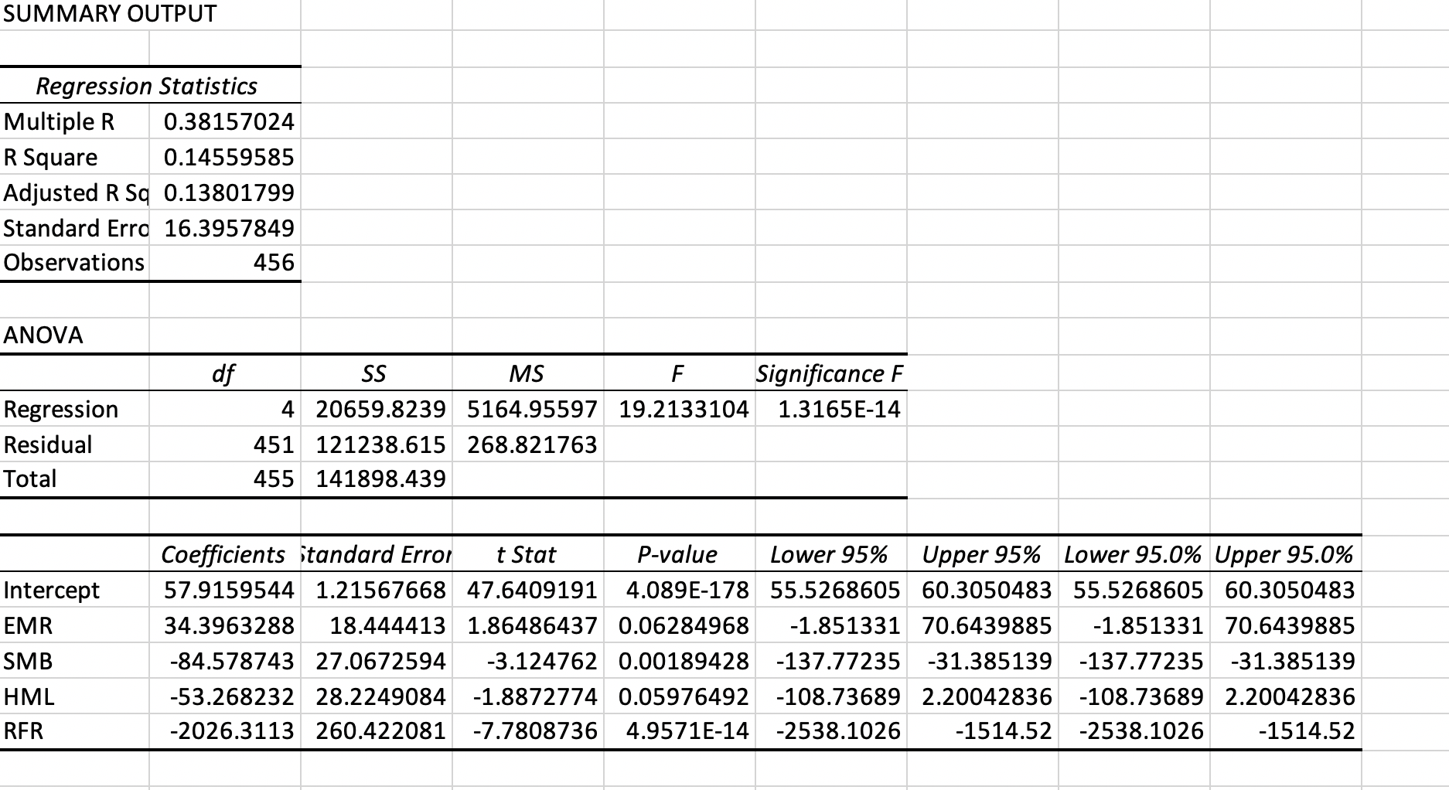
2c:
To show which coefficients were statistically significant I created a table in a separate worksheet using the overall p values as shown in the photo above (2b) and using the individual p-values as seen in part 2a. Using an excel IF formula, Excel analyzed the p-values to determine if they were statistically significant.
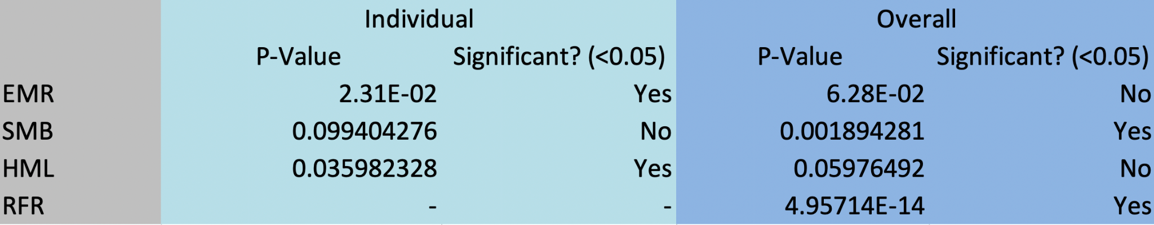
2D:
Using the R-Squared value and Adjusted R-Squared I created a table that compares the individual values for each (ERM, SMB, HML) values as well as compares the overall values.

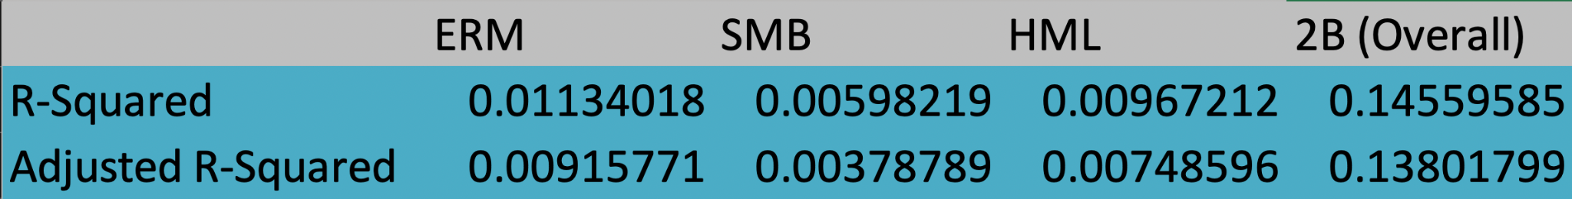
Section 2D required calculating the adjusted R-squared for each individual regression model and then comparing those values to the adjusted R-squared from the combined regression. I also evaluated how the results from part 2A (individual regressions) differed from those in part 2B (the overall model).
My results in part 2B differ from those in part 2A for two main reasons. First, part 2A involved running a separate regression for each factor (ERM, SMB, and HML), whereas part 2B estimated a single regression incorporating all the independent variables, including the risk-free rate. Due to the fact that these approaches use different model structures, variation in the R-squared values is expected.
A second key difference lies in the magnitude of the R-squared and adjusted R-squared measures. In the individual regressions (2A), both statistics are extremely small, and the difference between R-squared and adjusted R-squared is minimal for each factor. However, when all independent variables are included together in the overall model (2B), the R-squared increases substantially to approximately 0.1456, and the adjusted R-squared rises to 0.1380. This reflects the effect of combining explanatory variables and the model benefiting from additional information across the 456 observations.
Part (3) Foracasting
For the next stage of the analysis, I restricted my sample to only cover the years 1980 through 2000. Using this subset of the data, I estimated a regression model in which the stock return serves as the dependent variable, and the risk-free rate, excess market return, small-minus-big factor, and high-minus-low factor act as the independent variables (This is the same as before). This regression allows me to examine how these factors influenced returns specifically during this earlier period, and the results are presented in the following section.
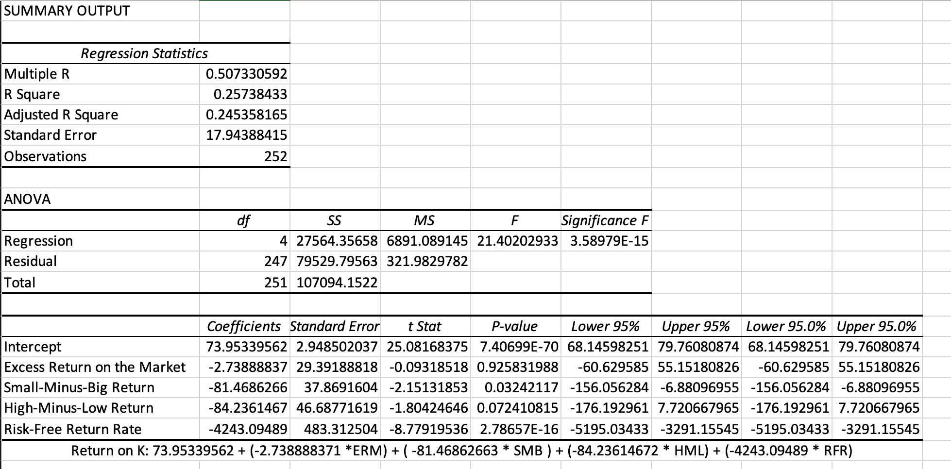
3b: Using this model to predict the stock values from 2001-2017 and to find the Root Mean Squared Error (RMSE) and sing the deviation between the actual stock price return over this period and the model-predicted stock price return over the same period.
- Step 1: Using the regression equation obtained in part 3A, compute the predicted monthly return based on the model’s coefficients.
- Step 2: Substitute all placeholder variables in the prediction formula, such as EMR, SMB, and the other Fama-French factors, with the actual monthly data starting in January 2002.
- Step 3: Once the formula is correctly structured and aligned with the dataset, fill it down through all rows corresponding to the months from 2002 to 2017, generating a full series of predicted returns.
- Step 4: At the beginning of the dataset, calculate the deviation for each month by subtracting the predicted return from the actual observed return.
- Step 5: Copy this deviation formula down the column for all months in the sample, then compute the squared deviation for each observation and extend that calculation down as well.
- Step 6: Apply Excel’s AVERAGE function to the squared deviations to determine the mean squared error across all months from 2002–2017.
- Step 7: Take the square root of the mean squared error to obtain the root mean squared error (RMSE).
With all these steps completed I calculated my Mean Deviation Squared for Kellanova was 413.393725 and the RMSE was 20.3320861.

Discussion:
To evaluate the strength of the relationship between Kellanova’s stock returns and the three Fama-French factors, Excess Market Return (EMR), Small Minus Big (SMB), and High Minus Low (HML) it is helpful to consider both the individual regressions from Part 2A and the combined regression from Part 2B. Across the individual models, each factor displayed only a very weak ability to explain movements in Kellanova’s stock returns. This is reflected in the extremely low R-squared values for each regression, which were all close to zero. These results suggest that, when considered on their own, EMR, SMB, and HML have very limited explanatory power for the firm’s return behavior.
In part 2B, when the variables were combined in a single regression, the explanatory power increased somewhat. The model shows that the overall R-squared value rose to 0.1456, and the adjusted R-squared to 0.1380. That indicates that the three factors together, along with the risk-free rate, capture a larger share of the variation in Kellanova’s returns than any other factor individually. Still, the model explains only about 14% (the combined regression table) of the total variation, meaning most month-to-month movements are driven by influences outside the Fama-French framework. This outcome is consistent with the idea that firm-specific events, industry developments, and macroeconomic shocks may play more significant roles in determining Kellanova’s returns than broad factor exposures alone.
When the model estimated using 1980–2000 data was used to forecast returns for 2001-2017, the resulting prediction errors were large. The mean squared error of 413.393725 and the RMSE of 20.3320861 indicate that the model performs poorly. This means the model’s predicted returns frequently deviate from the actual returns by a substantial margin. This is not just obvious in the RMSE but also when looking at the data side by side. This weak forecasting performance aligns with the low explanatory power observed earlier.
The results suggest that while the Fama-French factors are widely used in asset-pricing research, they do not offer a strong or reliable framework for explaining or predicting Kellanova’s individual stock returns over the sample period. The low R-squared values, the limited statistical significance of the coefficients, and the large prediction errors all support my conclusion that most of the variation in Kellanova’s monthly returns must come from influence not captured by EMR, SMB, HML, or the risk-free rate.

